**Chapter-1**

**INTRODUCTION**

**Chapter-1**

**INTRODUCTION**

**1.1 General Introduction-**

In order to maintain a good recognition at University/College, the management does every possible aspect in maintaining the qualities of the lecturers. One of the main evaluations done at the university is getting an anonymous student feedback at the end of each module at the end of the semester and getting an overall summary of the students’ viewpoints regarding the lecturer’s teaching.

To get productive feedback, the university has prepared a questionnaire to be filled by the students which covers the key points regarding a lecture.

Up to now, this task was done manually with the usage of papers and pens. This has many drawbacks and evaluating these handwritten forms is a difficult process. But this is the online era, where everything is online, and our college is one of the pioneers in this country introducing all online themes. The system comprises of generation and analysis of teacher’s feedback pages, summary, and a delivery of feedback. The system is developed for all college students and staff members Also Students can give opinion about their faculty members. The student must choose from excellent, very good, good, satisfactory, poor. Then after attempting every question must submit his feedback with the system. This online

feedback system is the perfect place to find feedback evaluated according to the requirements and it is the efficient one to get feedback analysis of students.

**1.2 Purpose of the project-**

The purpose of a feedback system is to gather information from stakeholders (such as customers, clients, employees, or students) to evaluate the quality of a product, service, or process. In the context of a university, the purpose of a feedback system is to gather feedback from students on their learning experience and the quality of teaching provided by the lecturers. The feedback system is designed to provide the management with an insight into the areas where improvements are needed, as well as to identify areas of strength. Based on the feedback, the management can take actions to improve the quality of teaching, enhance the learning experience, and ensure that students are achieving their learning outcomes. The feedback system also helps to ensure that the university meets the expectations and needs of its stakeholders, ultimately contributing to the overall success of the institution.

**1.3 Scope of the project-**

The scope of a feedback system in a university setting is to collect feedback from students on various aspects of their learning experience, such as the quality of teaching, the relevance of course content, the effectiveness of assessment methods, the availability of learning resources, and the overall learning environment. The scope also includes collecting feedback from other stakeholders such as faculty members, administrative staff, and external partners.

The feedback system should be designed to be comprehensive, covering all relevant aspects of the learning experience, while at the same time being simple and easy to use for the students. The system should be able to handle a large volume of feedback data and provide accurate and reliable results for analysis.

In addition to collecting feedback, the scope of the feedback system also includes analyzing the feedback data to identify trends, patterns, and areas for improvement. The analysis should be done in a timely manner, and the results should be communicated to the relevant stakeholders, such as the faculty members, the department heads, and the university management.

.

**Chapter-2**

**LITERATURE SURVEY**

**Chapter-2**

**LITERATURE SURVEY**

**2.1 Existing System-**

The existing system of a feedback system in a university setting typically involves collecting feedback from students at the end of each semester or module. Traditionally, this has been done using paper-based forms that are distributed to students in class, which they then fill out and submit anonymously.

However, with the growing trend towards digitalization, many universities are now transitioning to online feedback systems. These systems typically involve providing students with a link to an online feedback questionnaire, which they can complete from their computer or mobile device.

The online feedback system may have several features, such as a user-friendly interface, multiple question types, and options for anonymous feedback. The system may also include features for analyzing feedback data, such as generating reports and visualizations to help faculty and university administrators understand the feedback and take action to address any issues.

In addition to the student feedback system, some universities may also have a feedback system for faculty members. This system allows other faculty members or department heads to provide feedback on a colleague's teaching performance or other aspects of their job performance.

.

**2.2 Proposed System-**

A proposed system of a feedback system in a university setting would leverage the latest technologies and tools to make the feedback process more efficient, user-friendly, and insightful. Here are some key features that a proposed system could include:

* Online Platform: The proposed system would be an online platform accessible to all students and faculty members. Students can log in to the platform and access feedback questionnaires for each of their courses. Faculty members can also access the platform to view feedback on their performance.
* Customizable Questionnaires: The proposed system would allow for customizable questionnaires for each course. This way, faculty
* members can tailor the feedback questions to specific course objectives and learning outcomes.
* Multiple Question Types: The proposed system would include multiple question types, such as rating scales, multiple-choice questions, and open-ended questions. This way, students can provide detailed feedback on their experience.
* Real-Time Feedback: The proposed system would allow for real-time feedback, meaning students can provide feedback as they go through the course. This way, faculty members can adjust their teaching methods as needed.
* Anonymous Feedback: The proposed system would allow for anonymous feedback to ensure students feel comfortable providing honest feedback without fear of retribution.
* Data Analysis: The proposed system would include features for analyzing feedback data. This way, faculty members and university administrators can identify trends and patterns and take appropriate action.
* Actionable Insights: The proposed system would provide actionable insights based on the feedback data. This way, faculty members and university administrators can make data-driven decisions to improve the quality of teaching and learning.

**Chapter-3**

**PROJECT PLAN / ACTION PLAN**

**Chapter-3**

**PROJECT PLAN / ACTION PLAN**

**3.1 Project Planning-**

**Table No. 3.1:** Project Planning

**Sr. No. Activities Duration In Week**

1. Plan of project 01 Week

2. Designing / Module Formation 03 Week

3. Coding 03 Week

4. Testing 02 Week

5. Final Report Writing / Documentation 01 Week

**3.2 Gantt Chart-**

**Table No. 3.2:** Project Planning

**Activity Name**

**Month March April May June**

**Week 1 2 3 4 1 2 3 4 1 2 3 4 1 2 3 4**

Plan of Project

Designing and module

Formation

Coding

Testing

Final reporting writing/ Documentation

**Chapter-4**

**SYSTEM REQUIREMENTS**

**Chapter-4**

**SYSTEM REQUIREMENTS**

**4.1 Hardware Requirements-**

Table No. 4.1: Hardware Requirements

**Sr. No. Name of Component Specification**

1. **Processor**

Intel Core i3 or higher

2. **RAM** 128 MB

3. **Hard disk** 5GB or higher

4. **Memory**  1GB RAM or higher

5**. Keyboard , Monitor,Mouse**

**4.2 Software Requirement-**

|  |  |  |
| --- | --- | --- |
| Sr .No. | Software Particulars | Specification |
| 1 | **Operating System** | Windows XP , Windows 7 or higher |
| 2 | **Tools** | VS Code, Notepad++,Xamp |
| 3 | **Database Connectivity** | SQL , PHP, my admin |
| 4 | **Technologies used** | PHP , HTML, BOOT,Javascript,CSS |

Table No. 4.2: Software Requirements

**Chapter-5**

**SYSTEM ANALYSIS**

**Chapter-5**

**SYSTEM ANALYSIS**

**5.1 Use Case Diagram**

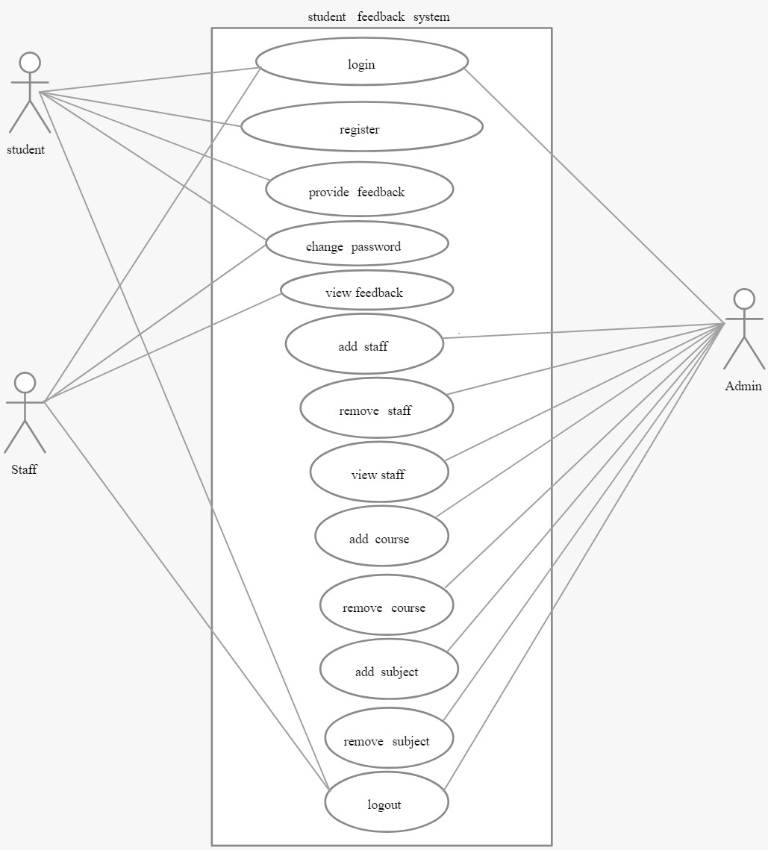

Figure No 5.1-Use Case Di

**5.2 DFD Diagram-**

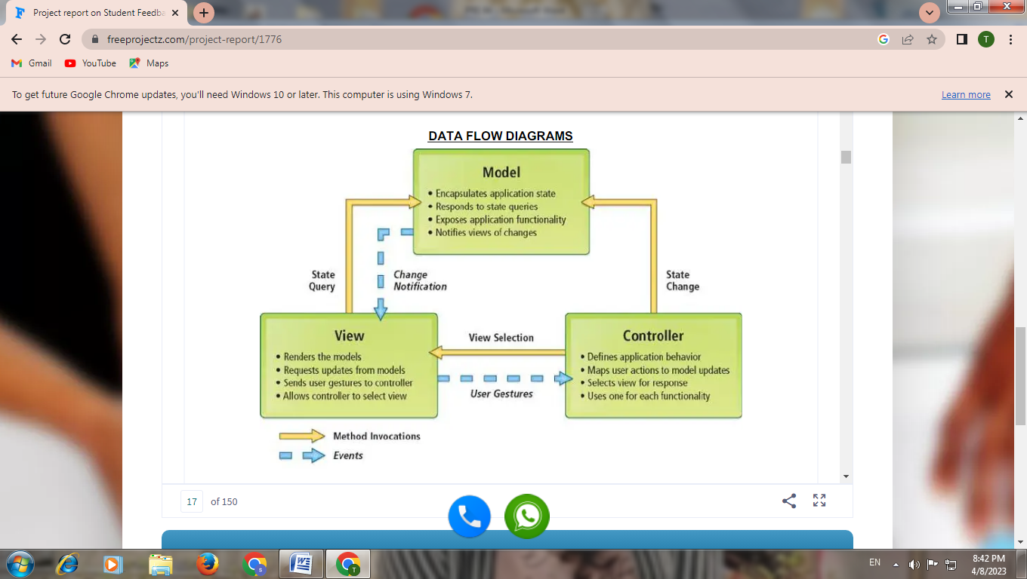

**5.3 Activity Diagram-**

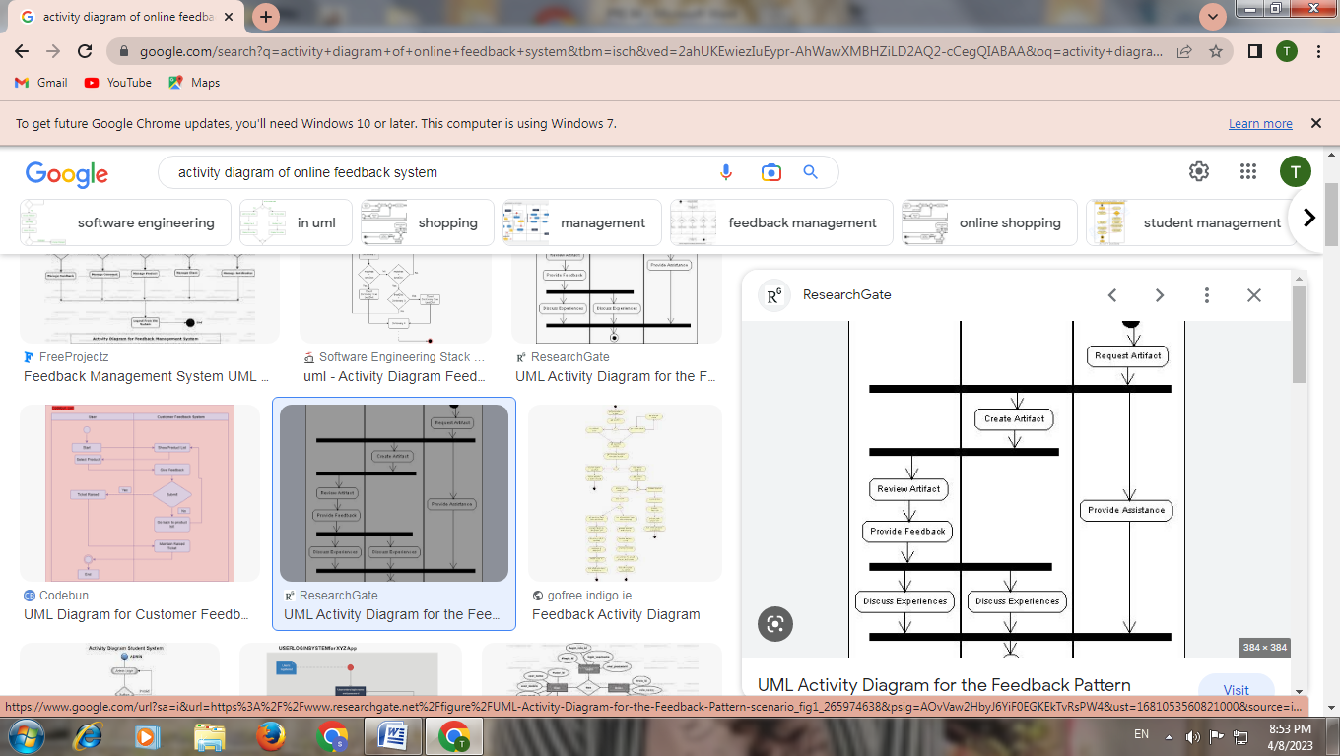

Figure No 5.5: Activity Diagram

**Chapter-6**

**FEASIBILITY STUDY**

**Chapter-6**

**FEASIBILITY STUDY**

**6.1 Feasibility Study-**

A feasibility study is a preliminary evaluation of a proposed system to determine if it is practical, achievable, and financially viable. In the case of a feedback system in a university setting, a feasibility study would assess the potential benefits and costs of implementing the system, as well as the technical, operational, and cultural feasibility.

Here are some factors to consider in a feasibility study of a feedback system:

Technical Feasibility: The proposed system must be technically feasible, meaning it can be implemented with the available technology infrastructure and resources.

Operational Feasibility: The proposed system must be operationally feasible, meaning it can be integrated with the existing systems and processes at the university without causing disruptions.

Cultural Feasibility: The proposed system must be culturally feasible, meaning it aligns with the values, beliefs, and expectations of the university stakeholders.

Economic Feasibility: The proposed system must be economically feasible, meaning the benefits of the system outweigh the costs of implementing and maintaining it

**6.2 Types of Feasibility**

1. **Traditional paper-based feedback system**:

This is the traditional method of collecting feedback from students, where they are given paper forms to fill out.

1. **Online feedback system:**

This system uses an online platform to collect feedback from students, which makes the process more efficient and streamlined

1. **Mobile feedback system**:

This system allows students to provide feedback using their mobile devices, which makes it more convenient and accessible.

**4 ) Real-time feedback system**:

This system collects feedback from students in real-time, allowing for immediate feedback and adjustments to be made.

**Chapter-7**

**TECHNICAL OVERVIEW**

**Chapter-7**

**TECHNICAL OVERVIEW**

**7.1 Hardware Implementation-**

**1) Processor-**

* Processors are an essential component of web-based systems because they allow the system to execute the necessary instructions to perform the desired functions. When a user interacts with a web application, such as submitting a form or clicking a button, the processor receives that input and executes the appropriate actions.
* Processors enable web applications to perform complex operations such as database queries, file processing, and mathematical calculations, which are critical for delivering a rich user experience. Additionally, processors are responsible for managing resources, scheduling tasks, and ensuring that the application is running efficiently.
* Without a processor, a web-based system would be unable to perform any meaningful work, and users would be unable to interact with it. Therefore, processors are a crucial component of any web-based system, and their capabilities and performance directly impact the overall functionality and user experience of the application.

**2) Hard Disk –**

* Hard disks are used in web-based systems primarily for storage purposes. When a user interacts with a web application, various types of data are generated, such as user profiles, transaction logs, media files, and other types of data.
* Hard disks provide a high-capacity, low-cost means of storing this data. The data stored on hard disks can be accessed quickly and efficiently by the processor, allowing the system to retrieve the necessary information and serve it to the user as quickly as possible.
* In addition, hard disks allow web-based systems to store data persistently, meaning that the data remains available even if the system is shut down or restarted. This is critical for web applications that require data to be available 24/7, such as e-commerce platforms or social media networks.

**3) Memory -**

* Memory (also known as RAM, or Random Access Memory) is used in web-based systems to store data and instructions temporarily while the system is running. When a user interacts with a web application, the processor retrieves the necessary instructions and data from memory, executes the instructions, and then stores the results back in memory.
* Memory is critical in web-based systems because it allows the system to access data quickly and efficiently. When a user requests a web page, the system retrieves the necessary data and instructions from memory, and the processor uses this data to generate the web page.
* Memory is also essential for multitasking in web-based systems. When multiple users are interacting with a web application simultaneously, the system needs to be able to switch between tasks quickly and efficiently. Memory allows the system to store the necessary data and instructions for each task temporarily, allowing the processor to switch between tasks rapidly.

**4) Monitor, Keyboard , Mouse-**

* Monitors, keyboards, and mice are essential components of web-based systems because they allow users to interact with the system and receive visual feedback.
* Monitors are used to display the web pages and user interfaces generated by the system, allowing users to view and interact with the content. Monitors come in a variety of sizes and resolutions, and the choice of monitor depends on factors such as the application's requirements and the user's preferences.
* The mouse is a common input device for web-based projects because it provides a way for users to interact with graphical user interfaces (GUIs) and webpages.
* With a mouse, users can click on buttons, links, and other interactive elements on a webpage to navigate, select, and manipulate content. Additionally, the mouse provides a way for users to point and highlight elements on the screen, which can be useful for conveying information or drawing attention to specific parts of a webpage.
* While there are other input devices, such as touchscreens and keyboards, the mouse has become a standard input device for web-based projects due to its ease of use and widespread availability. It also allows for precise movements and interactions, which can be important for tasks such as image editing or selecting small elements on a webpage.

**7.2 Software Implementation-**

1. **Operating System-**

* Web servers are typically powered by an operating system such as Linux or Windows, which provides a foundation for running web applications and managing resources such as files, databases, and network connections. The operating system provides essential services such as managing system resources, scheduling tasks, and providing security features to protect against threats such as malware and hacking attempts.
* Additionally, developers may use an operating system on their local computers to build and test web-based projects before deploying them to a web server. This can include using tools and technologies such as web development frameworks, text editors, and testing environments to build and debug web applications.

1. **Tools-**

Tools are essential in web-based projects for various reasons. They can help developers streamline their workflow, increase productivity, and improve the quality of their code. Here are some reasons why tools are used in web-based projects:

* Efficiency: Web development tools can automate repetitive tasks, such as testing and deployment, saving developers time and effort.
* Collaboration: Many web development tools support collaboration between team members, allowing multiple developers to work on the same codebase simultaneously.
* Quality assurance: Testing tools can help developers ensure that their code is functioning as intended and meets the desired quality standards.
* Debugging: Debugging tools can help developers identify and fix issues in their code, improving the overall quality of the web-based project.
* Scalability: Tools can help developers build scalable web-based projects, which can handle a high volume of traffic and users.
* User experience: Tools can help developers create engaging user experiences by providing features such as animations, interactive elements, and responsive design.

.

1. **Database Connectivity-**

Database connectivity is used in web-based projects to enable the storage, retrieval, and manipulation of data. Here are some reasons why database connectivity is essential in web-based projects:

* Data storage: Databases provide a secure and efficient way to store large amounts of data, such as user information, product catalogs, and other essential information.
* Data retrieval: Database connectivity allows web applications to retrieve data from a database quickly and efficiently, enabling dynamic and responsive user experiences.
* Data manipulation: Databases provide powerful tools for manipulating data, allowing developers to perform complex queries, joins, and other operations to extract valuable insights from large datasets.
* Security: Databases can provide built-in security features, such as access controls and encryption, to ensure that sensitive data is protected from unauthorized access or theft.
* Scalability: Databases can be scaled up or down to handle varying levels of traffic and data volume, allowing web applications to grow and adapt to changing user needs.
* Integration: Databases can be integrated with other technologies, such as web development frameworks and APIs, to enable powerful and flexible web-based solutions.

1. **Technologies used-**

Database connectivity is used in web-based projects to enable the storage, retrieval, and manipulation of data. Here are some reasons why database connectivity is essential in web-based projects:

* Data storage: Databases provide a secure and efficient way to store large amounts of data, such as user information, product catalogs, and other essential information.
* Data retrieval: Database connectivity allows web applications to retrieve data from a database quickly and efficiently, enabling dynamic and responsive user experiences.
* Data manipulation: Databases provide powerful tools for manipulating data, allowing developers to perform complex queries, joins, and other operations to extract valuable insights from large datasets.
* Security: Databases can provide built-in security features, such as access controls and encryption, to ensure that sensitive data is protected from unauthorized access or theft.
* Scalability: Databases can be scaled up or down to handle varying levels of traffic and data volume, allowing web applications to grow and adapt to changing user needs.
* Integration: Databases can be integrated with other technologies, such as web development frameworks and APIs, to enable powerful and flexible web-based solutions.

.

**Chapter-8**

**APPLICATION & ADVANTAGES**

**Chapter-8**

**APPLICATION AND ADVANTAGES**

**8.1 Applications-**

Improving Teaching Quality: Feedback helps to identify areas where instructors can improve their teaching methods and enhance their instructional materials. By acting on feedback, instructors can increase their effectiveness and improve student learning outcomes.

Increasing Student Engagement: Feedback systems give students a voice, which increases their engagement with the course and fosters a sense of ownership over their learning.

Providing Insight into Course Effectiveness: Feedback systems provide valuable insights into the effectiveness of the course as a whole. They allow instructors and university administrators to evaluate the course materials, assessments, and learning outcomes, and make changes as needed.

Enhancing Accountability: Feedback systems hold instructors and university administrators accountable for their performance. This creates a culture of accountability and continuous improvement.

Facilitating Continuous Improvement: Feedback systems facilitate continuous improvement by providing an ongoing source of feedback for instructors and university administrators. By acting on feedback, they can make improvements and enhance the overall quality of the course.

Promoting Student Satisfaction: Feedback systems promote student satisfaction by giving students a platform to voice their opinions and concerns. When students feel heard and valued, they are more likely to be satisfied with the course and the university.

**8.2 Student Feedback System**

* Improving Teaching Quality: Feedback helps to identify areas where instructors can improve their teaching methods and enhance their instructional materials. By acting on feedback, instructors can increase their effectiveness and improve student learning outcomes.
* Increasing Student Engagement: Feedback systems give students a voice, which increases their engagement with the course and fosters a sense of ownership over their learning.
* Providing Insight into Course Effectiveness: Feedback systems provide valuable insights into the effectiveness of the course as a whole. They allow instructors and university administrators to evaluate the course materials, assessments, and learning outcomes, and make changes as needed.
* Enhancing Accountability: Feedback systems hold instructors and university administrators accountable for their performance. This creates a culture of accountability and continuous improvement.
* Facilitating Continuous Improvement: Feedback systems facilitate continuous improvement by providing an ongoing source of feedback for instructors and university administrators. By acting on feedback, they can make improvements and enhance the overall quality of the course.
* Promoting Student Satisfaction: Feedback systems promote student satisfaction by giving students a platform to voice their opinions and concerns. When students feel heard and valued, they are more likely to be satisfied with the course and the university.

**Limitations of student feedback system**

* Limited Response Rates: Despite the convenience of online feedback systems, students may still choose not to participate in providing feedback. This can limit the overall response rate, leading to potential bias in the results.
* Bias in Feedback: The feedback provided by students can sometimes be biased and subjective. Students may be influenced by factors such as their personal feelings towards the
* instructor, their own performance in the course, or external factors outside of the instructor's control.
* Limited Feedback Scope: The questions asked in feedback forms may be limited in scope and may not capture all relevant aspects of the course. This can lead to important issues being overlooked or not addressed.
* Potential Misinterpretation of Results: The interpretation of feedback results can be challenging and requires careful analysis. Misinterpretation of results can lead to incorrect conclusions and potentially inappropriate action.
* Limited Actionability of Feedback: Feedback may not always result in actionable changes. Instructors and university administrators may not be able to address all the feedback provided or may not have the resources to make the changes suggested.

**Chapter-9**

**CODE AND RSULTS**

**Chapter-9**

**CODE AND RSULTS**

**Index.php**

<!DOCTYPE html>

<html lang="en">

<?php session_start() ?>

<?php

if(!isset($_SESSION['login_id']))

header('location:login.php');

include 'db_connect.php';

ob_start();

if(!isset($_SESSION['system'])){

$system = $conn->query("SELECT * FROM system_settings")->fetch_array();

foreach($system as $k => $v){

$_SESSION['system'][$k] = $v;

}

}

ob_end_flush();

include 'header.php'

?>

<body class="hold-transition sidebar-mini layout-fixed layout-navbar-fixed layout-footer-fixed">

<div class="wrapper">

<?php include 'topbar.php' ?>

<?php include $_SESSION['login_view_folder'].'sidebar.php' ?>

<!-- Content Wrapper. Contains page content -->

<div class="content-wrapper">

<div class="toast" id="alert_toast" role="alert" aria-live="assertive" aria-atomic="true">

<div class="toast-body text-white">

</div>

</div>

<div id="toastsContainerTopRight" class="toasts-top-right fixed"></div>

<!-- Content Header (Page header) -->

<div class="content-header">

<div class="container-fluid">

<div class="row mb-2">

<div class="col-sm-6">

<h1 class="m-0"><?php echo $title ?></h1>

</div><!-- /.col -->

</div><!-- /.row -->

<hr class="border-primary">

</div><!-- /.container-fluid -->

</div>

<!-- /.content-header -->

<!-- Main content -->

<section class="content">

<div class="container-fluid">

<?php

$page = isset($_GET['page']) ? $_GET['page'] : 'home';

if(!file_exists($_SESSION['login_view_folder'].$page.".php")){

include '404.html';

}else{

include $_SESSION['login_view_folder'].$page.'.php';

}

?>

</div><!--/. container-fluid -->

</section>

<!-- /.content -->

<div class="modal fade" id="confirm_modal" role='dialog'>

<div class="modal-dialog modal-md" role="document">

<div class="modal-content">

<div class="modal-header">

<h5 class="modal-title">Confirmation</h5>

</div>

<div class="modal-body">

<div id="delete_content"></div>

</div>

<div class="modal-footer">

<button type="button" class="btn btn-primary" id='confirm' onclick="">Continue</button>

<button type="button" class="btn btn-secondary" data-dismiss="modal">Close</button>

</div>

</div>

</div>

</div>

<div class="modal fade" id="uni_modal" role='dialog'>

<div class="modal-dialog modal-md" role="document">

<div class="modal-content">

<div class="modal-header">

<h5 class="modal-title"></h5>

</div>

<div class="modal-body">

</div>

<div class="modal-footer">

<button type="button" class="btn btn-primary" id='submit' onclick="$('#uni_modal form').submit()">Save</button>

<button type="button" class="btn btn-secondary" data-dismiss="modal">Cancel</button>

</div>

</div>

</div>

</div>

<div class="modal fade" id="uni_modal_right" role='dialog'>

<div class="modal-dialog modal-full-height modal-md" role="document">

<div class="modal-content">

<div class="modal-header">

<h5 class="modal-title"></h5>

<button type="button" class="close" data-dismiss="modal" aria-label="Close">

<span class="fa fa-arrow-right"></span>

</button>

</div>

<div class="modal-body">

</div>

</div>

</div>

</div>

<div class="modal fade" id="viewer_modal" role='dialog'>

<div class="modal-dialog modal-md" role="document">

<div class="modal-content">

<button type="button" class="btn-close" data-dismiss="modal"><span class="fa fa-times"></span></button>

<img src="" alt="">

</div>

</div>

</div>

</div>

<!-- /.content-wrapper -->

<!-- Control Sidebar -->

<aside class="control-sidebar control-sidebar-dark">

<!-- Control sidebar content goes here -->

</aside>

<!-- /.control-sidebar -->

<!-- Main Footer -->

<footer class="main-footer">

<strong>Copyright &copy; 2023 <a href="https://wa.link/6k4ean">Utkarsha Pansare</a>.</strong>

All rights reserved.

<div class="float-right d-none d-sm-inline-block">

<b><?php echo $_SESSION['system']['name'] ?></b>

</div>

</footer>

</div>

<!-- ./wrapper -->

<!-- REQUIRED SCRIPTS -->

<!-- jQuery -->

<!-- Bootstrap -->

<?php include 'footer.php' ?>

</body>

</html>

**Login.php**

<!DOCTYPE html>

<html lang="en">

<?php

session_start();

include('./db_connect.php');

ob_start();

// if(!isset($_SESSION['system'])){

$system = $conn->query("SELECT * FROM system_settings")->fetch_array();

foreach($system as $k => $v){

$_SESSION['system'][$k] = $v;

}

// }

ob_end_flush();

?>

<?php

if(isset($_SESSION['login_id']))

header("location:index.php?page=home");

?>

<?php include 'header.php' ?>

<body class="hold-transition login-page bg-black">

<h2><b> SHIVNAGAR VIDYA PRASARAK MANDAL'S

COLLEGE OF ENGINEERING, MALEGAON (BK)-BARAMATI </b></h2> <br>

<h2><b> Feedback System </b></h2>

<div class="login-box">

<div class="login-logo">

<a href="#" class="text-white"></a>

</div>

<!-- /.login-logo -->

<div class="card">

<div class="card-body login-card-body">

<form action="" id="login-form">

<div class="input-group mb-3">

<input type="email" class="form-control" name="email" required placeholder="Email">

<div class="input-group-append">

<div class="input-group-text">

<span class="fas fa-envelope"></span>

</div>

</div>

</div>

<div class="input-group mb-3">

<input type="password" class="form-control" name="password" required placeholder="Password">

<div class="input-group-append">

<div class="input-group-text">

<span class="fas fa-lock"></span>

</div>

</div>

</div>

<div class="form-group mb-3">

<label for="">Login As</label>

<select name="login" id="" class="custom-select custom-select-sm">

<option value="3">Student</option>

<option value="2">Faculty</option>

<option value="1">Admin</option>

</select>

</div>

<div class="row">

<div class="col-8">

<div class="icheck-primary">

<input type="checkbox" id="remember">

<label for="remember">

Remember Me

</label>

</div>

</div>

<!-- /.col -->

<div class="col-4">

<button type="submit" class="btn btn-primary btn-block">Sign In</button>

</div>

<!-- /.col -->

</div>

</form>

</div>

<!-- /.login-card-body -->

</div>

</div>

<!-- /.login-box -->

<script>

$(document).ready(function(){

$('#login-form').submit(function(e){

e.preventDefault()

start_load()

if($(this).find('.alert-danger').length > 0 )

$(this).find('.alert-danger').remove();

$.ajax({

url:'ajax.php?action=login',

method:'POST',

data:$(this).serialize(),

error:err=>{

console.log(err)

end_load();

},

success:function(resp){

if(resp == 1){

location.href ='index.php?page=home';

}else{

$('#login-form').prepend('<div class="alert alert-danger">Username or password is incorrect.</div>')

end_load();

}

}

})

})

})

</script>

<?php include 'footer.php' ?>

</body>

</html>

**Admin Home.php**

<?php include('db_connect.php'); ?>

<?php

function ordinal_suffix1($num){

$num = $num % 100; // protect against large numbers

if($num < 11 || $num > 13){

switch($num % 10){

case 1: return $num.'st';

case 2: return $num.'nd';

case 3: return $num.'rd';

}

}

return $num.'th';

}

$astat = array("Not Yet Started","On-going","Closed");

?>

<div class="col-12">

<div class="card">

<div class="card-body">

Welcome <?php echo $_SESSION['login_name'] ?>!

<br>

<div class="col-md-5">

<div class="callout callout-info">

<h5><b>Academic Year: <?php echo $_SESSION['academic']['year'].' '.(ordinal_suffix1($_SESSION['academic']['semester'])) ?> Semester</b></h5>

<h6><b>Evaluation Status: <?php echo $astat[$_SESSION['academic']['status']] ?></b></h6>

</div>

</div>

</div>

</div>

</div>

<div class="row">

<div class="col-12 col-sm-6 col-md-4">

<div class="small-box bg-light shadow-sm border">

<div class="inner">

<h3><?php echo $conn->query("SELECT * FROM faculty_list ")->num_rows; ?></h3>

<p>Total Faculties</p>

</div>

<div class="icon">

<i class="fa fa-user-friends"></i>

</div>

</div>

</div>

<div class="col-12 col-sm-6 col-md-4">

<div class="small-box bg-light shadow-sm border">

<div class="inner">

<h3><?php echo $conn->query("SELECT * FROM student_list")->num_rows; ?></h3>

<p>Total Students</p>

</div>

<div class="icon">

<i class="fa ion-ios-people-outline"></i>

</div>

</div>

</div>

<div class="col-12 col-sm-6 col-md-4">

<div class="small-box bg-light shadow-sm border">

<div class="inner">

<h3><?php echo $conn->query("SELECT * FROM users")->num_rows; ?></h3>

<p>Total Users</p>

</div>

<div class="icon">

<i class="fa fa-users"></i>

</div>

</div>

</div>

<div class="col-12 col-sm-6 col-md-4">

<div class="small-box bg-light shadow-sm border">

<div class="inner">

<h3><?php echo $conn->query("SELECT * FROM class_list")->num_rows; ?></h3>

<p>Total Classes</p>

</div>

<div class="icon">

<i class="fa fa-list-alt"></i>

</div>

</div>

</div>

</div>

**Manage User.php**

<?php

include('db_connect.php');

session_start();

if(isset($_GET['id'])){

$type = array("","users","faculty_list","student_list");

$user = $conn->query("SELECT * FROM {$type[$_SESSION['login_type']]} where id =".$_GET['id']);

foreach($user->fetch_array() as $k =>$v){

$meta[$k] = $v;

}

}

?>

<div class="container-fluid">

<div id="msg"></div>

<form action="" id="manage-user">

<input type="hidden" name="id" value="<?php echo isset($meta['id']) ? $meta['id']: '' ?>">

<div class="form-group">

<label for="name">First Name</label>

<input type="text" name="firstname" id="firstname" class="form-control" value="<?php echo isset($meta['firstname']) ? $meta['firstname']: '' ?>" required>

</div>

<div class="form-group">

<label for="name">Last Name</label>

<input type="text" name="lastname" id="lastname" class="form-control" value="<?php echo isset($meta['lastname']) ? $meta['lastname']: '' ?>" required>

</div>

<div class="form-group">

<label for="email">Email</label>

<input type="text" name="email" id="email" class="form-control" value="<?php echo isset($meta['email']) ? $meta['email']: '' ?>" required autocomplete="off">

</div>

<div class="form-group">

<label for="password">Password</label>

<input type="password" name="password" id="password" class="form-control" value="" autocomplete="off">

<small><i>Leave this blank if you dont want to change the password.</i></small>

</div>

<div class="form-group">

<label for="" class="control-label">Avatar</label>

<div class="custom-file">

<input type="file" class="custom-file-input rounded-circle" id="customFile" name="img" onchange="displayImg(this,$(this))">

<label class="custom-file-label" for="customFile">Choose file</label>

</div>

</div>

<div class="form-group d-flex justify-content-center">

<img src="<?php echo isset($meta['avatar']) ? 'assets/uploads/'.$meta['avatar'] :'' ?>" alt="" id="cimg" class="img-fluid img-thumbnail">

</div>

</form>

</div>

<style>

img#cimg{

height: 15vh;

width: 15vh;

object-fit: cover;

border-radius: 100% 100%;

}

</style>

<script>

function displayImg(input,_this) {

if (input.files && input.files[0]) {

var reader = new FileReader();

reader.onload = function (e) {

$('#cimg').attr('src', e.target.result);

}

reader.readAsDataURL(input.files[0]);

}

}

$('#manage-user').submit(function(e){

e.preventDefault();

start_load()

$.ajax({

url:'ajax.php?action=update_user',

data: new FormData($(this)[0]),

cache: false,

contentType: false,

processData: false,

method: 'POST',

type: 'POST',

success:function(resp){

if(resp ==1){

alert_toast("Data successfully saved",'success')

setTimeout(function(){

location.reload()

},1500)

}else{

$('#msg').html('<div class="alert alert-danger">Username already exist</div>')

end_load()}

}

})

})

</script>

**RESULTS**

**Login Page**

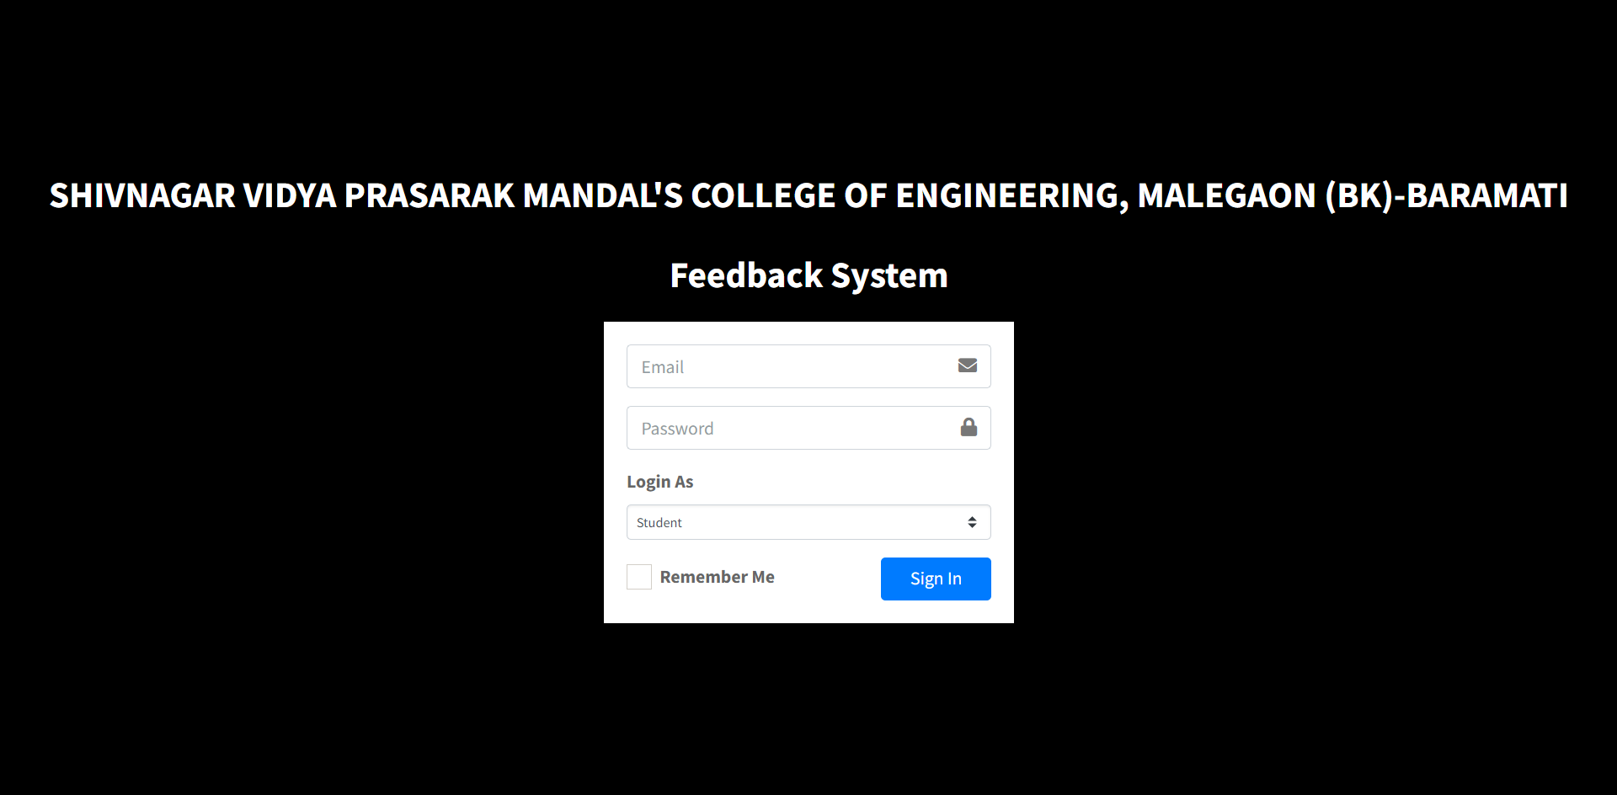

**Admin Home**

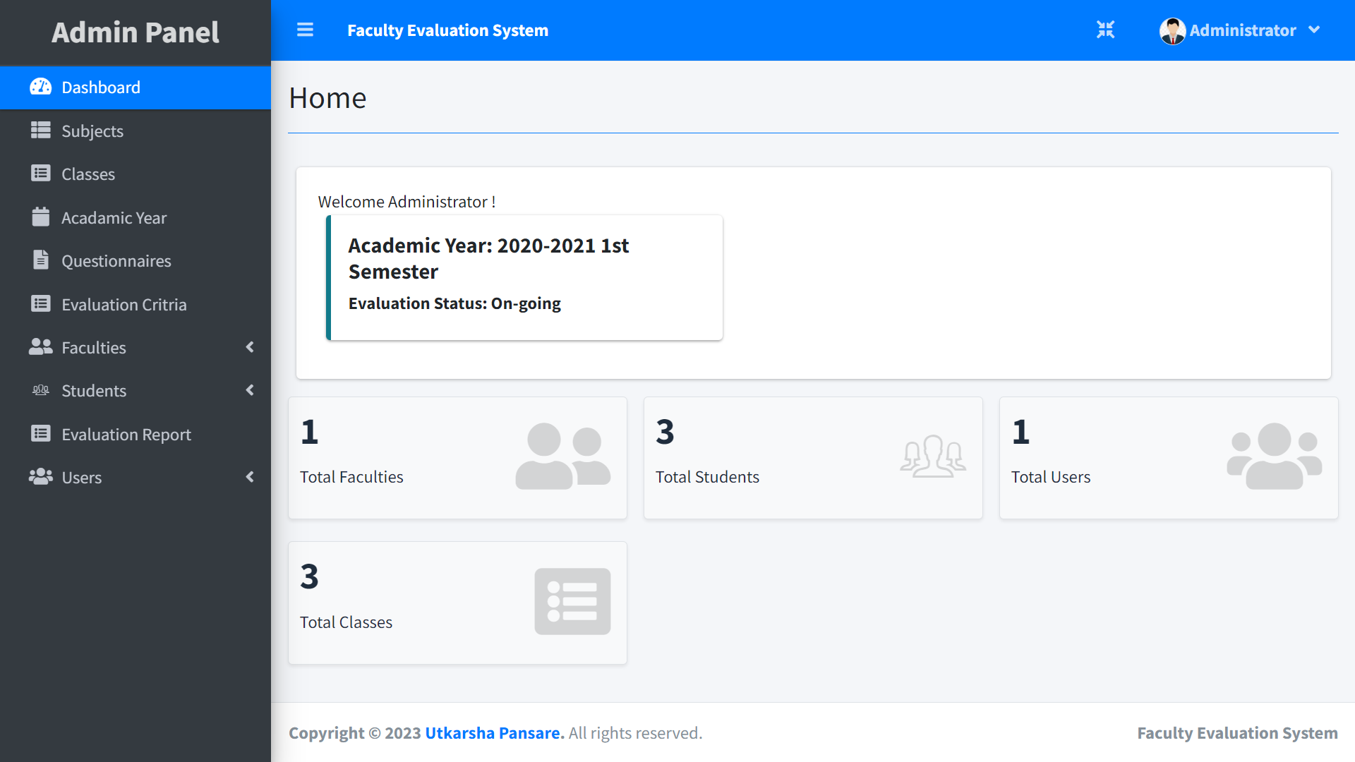

**Subject List**

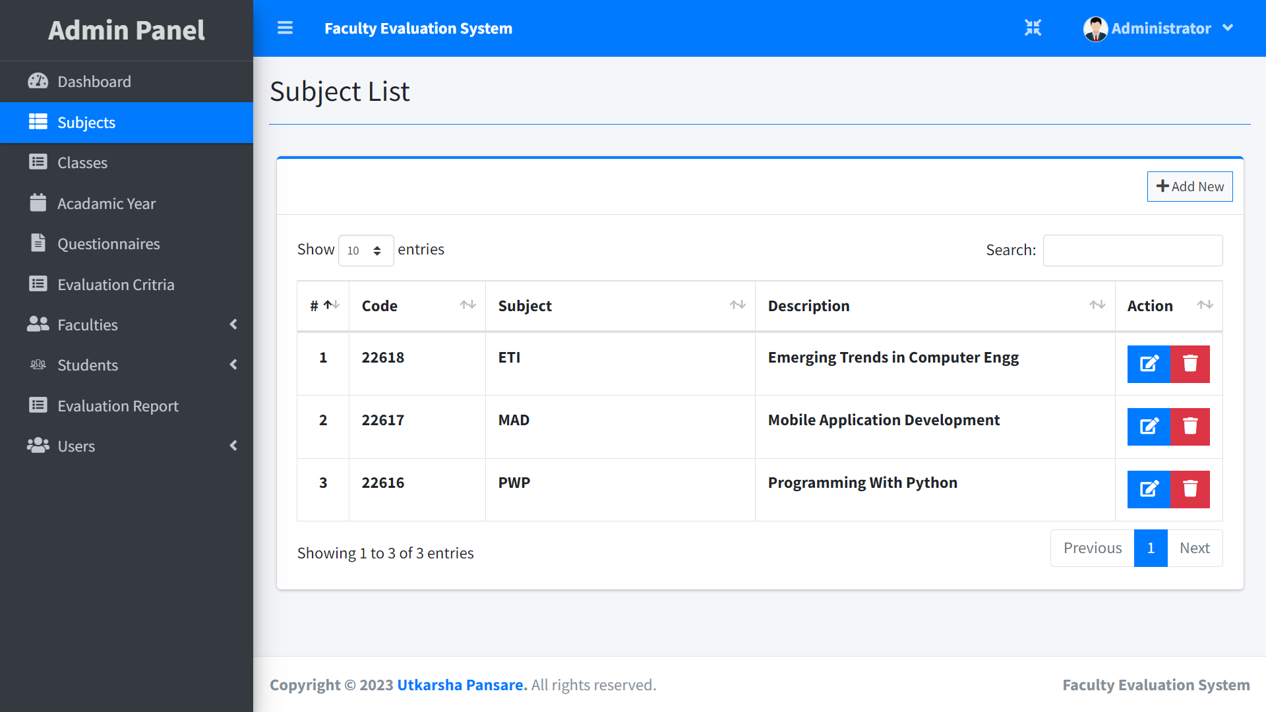

**Classes List**

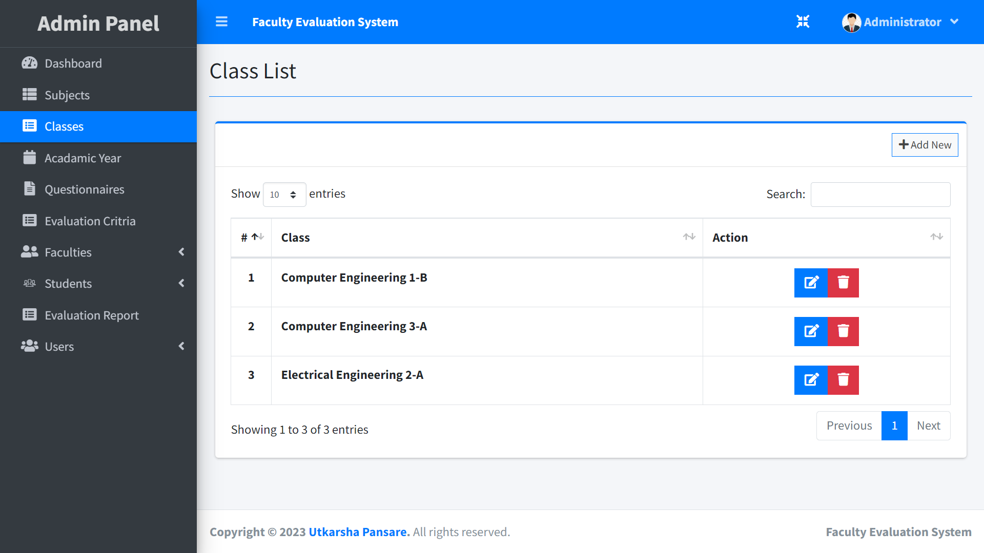

**Academic Year List**

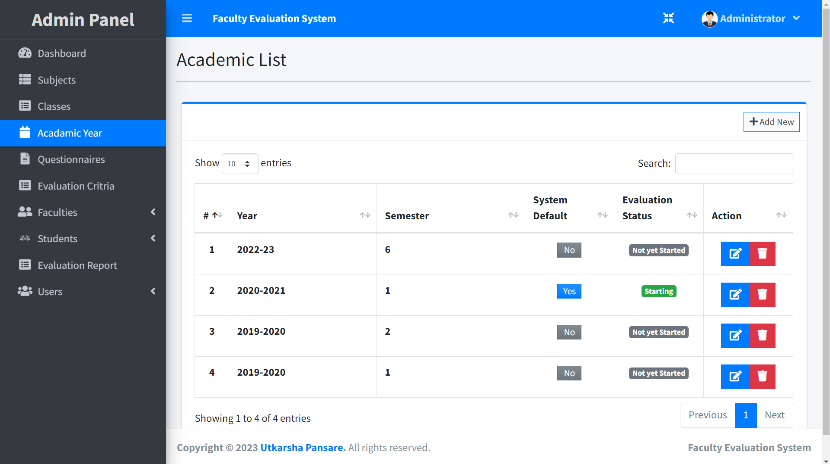

**Criteria List**

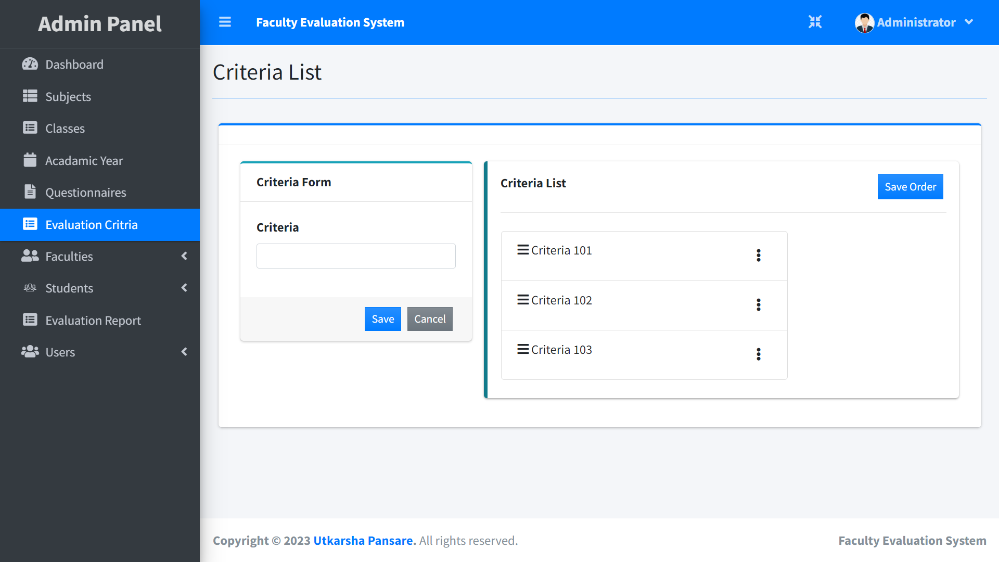

**Add Faculty**

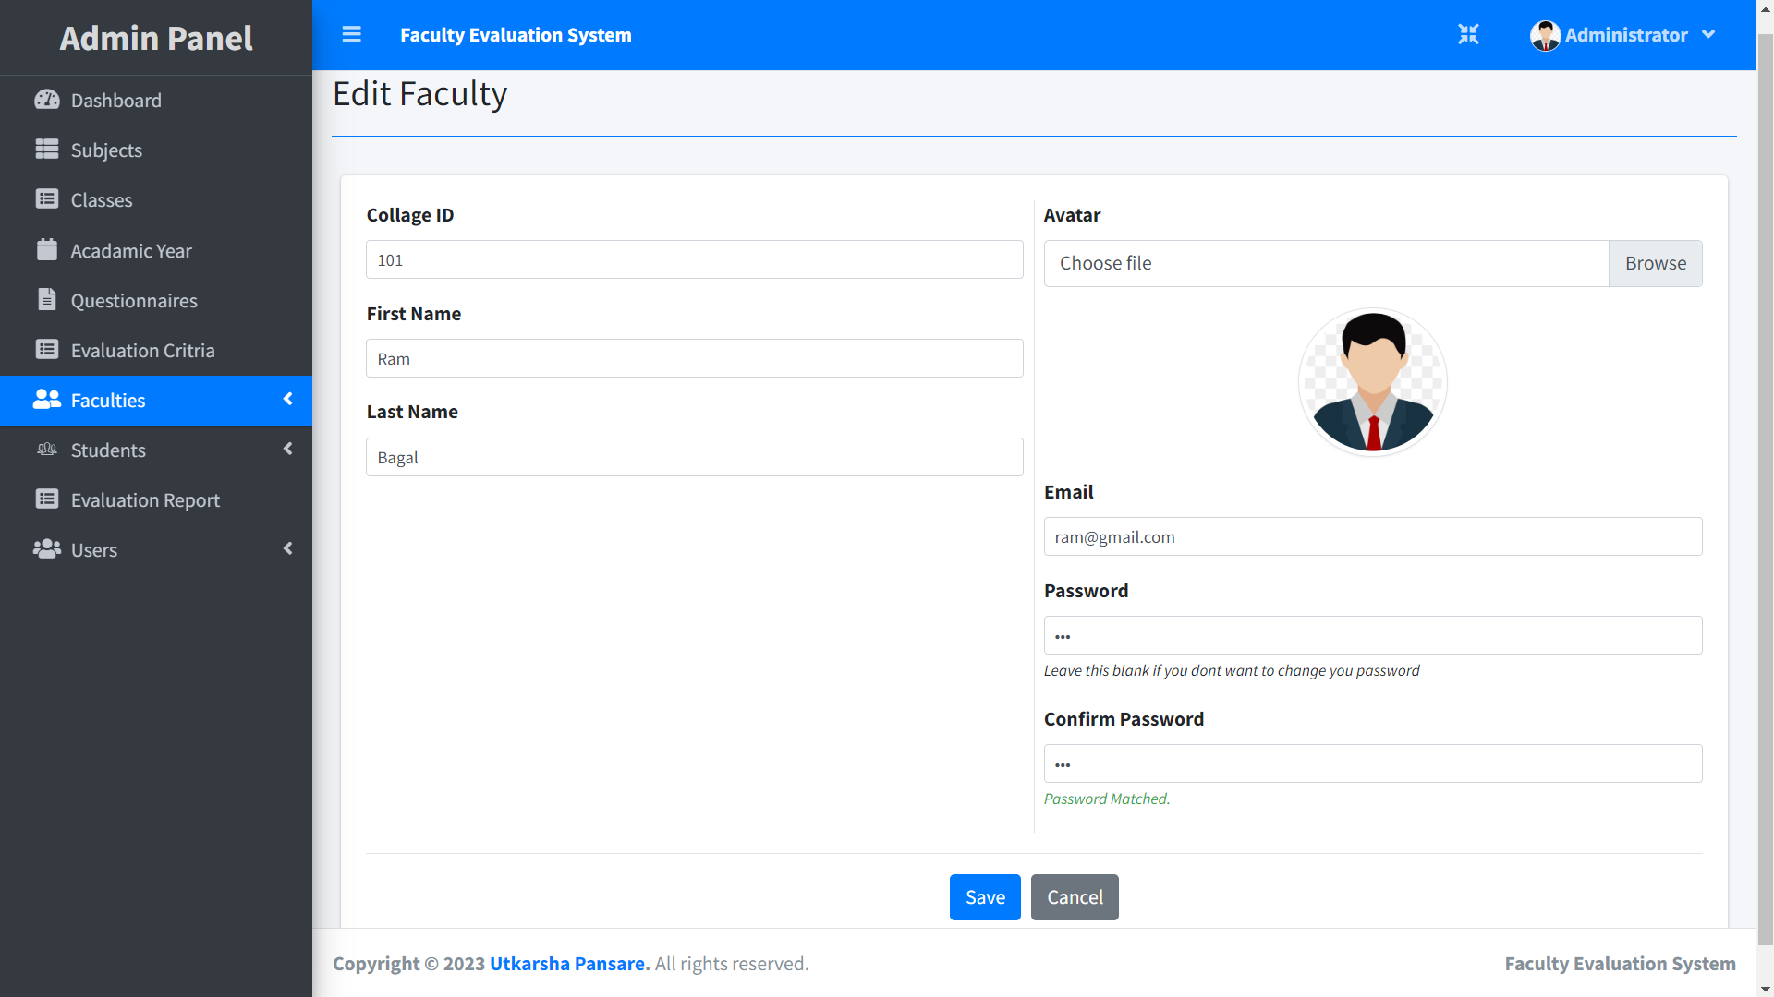

**Faculty List**

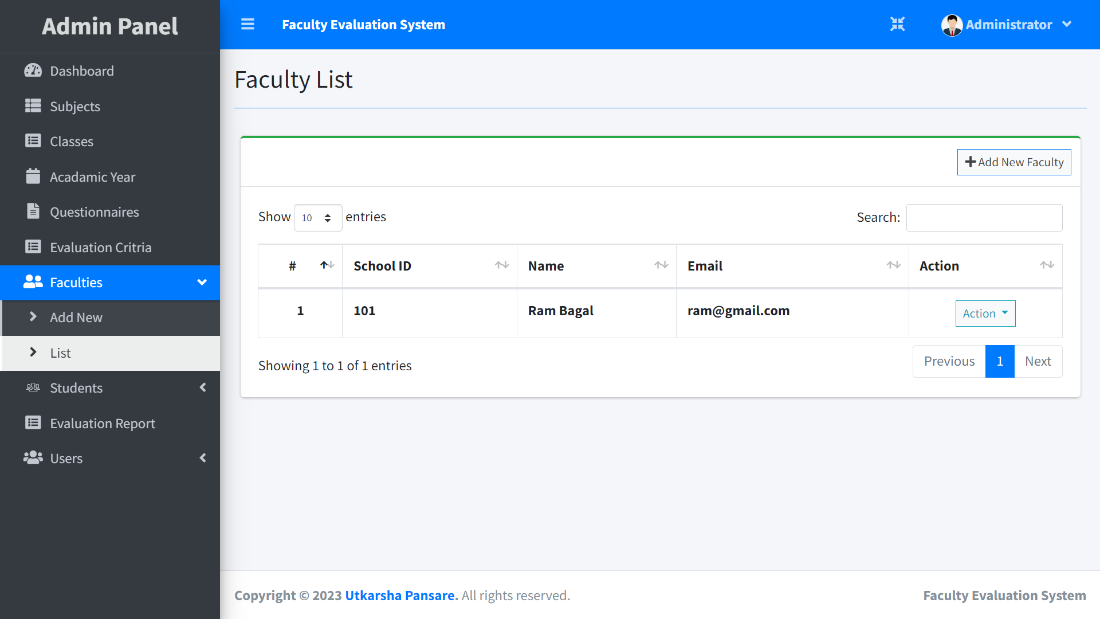

**Add Student**

**Student List**

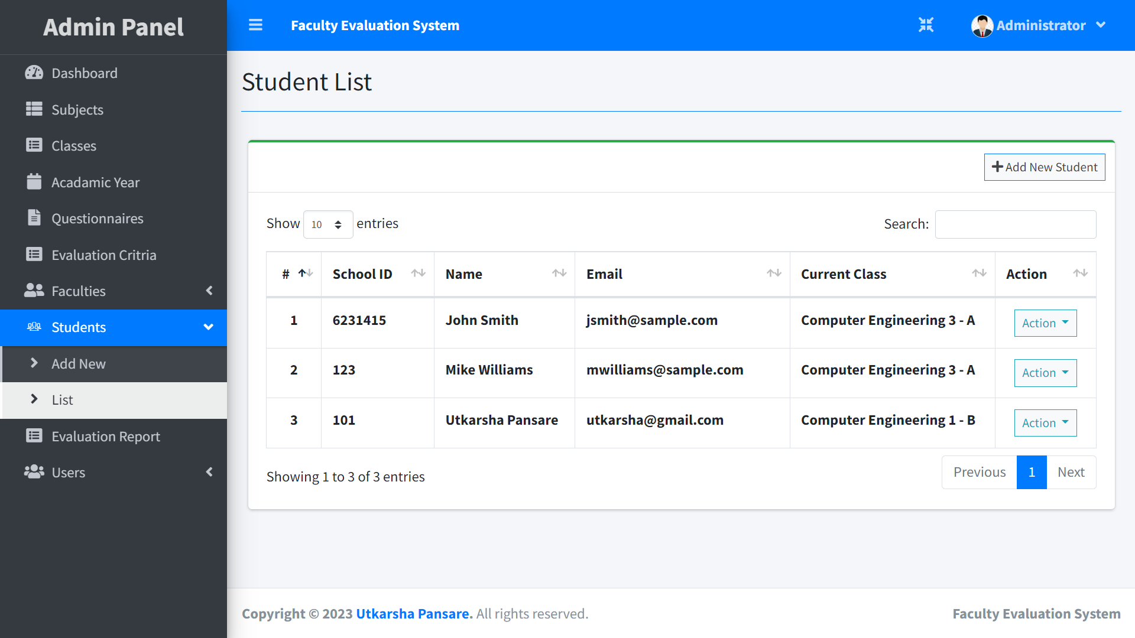

**Evaluation Report For Each Staff**

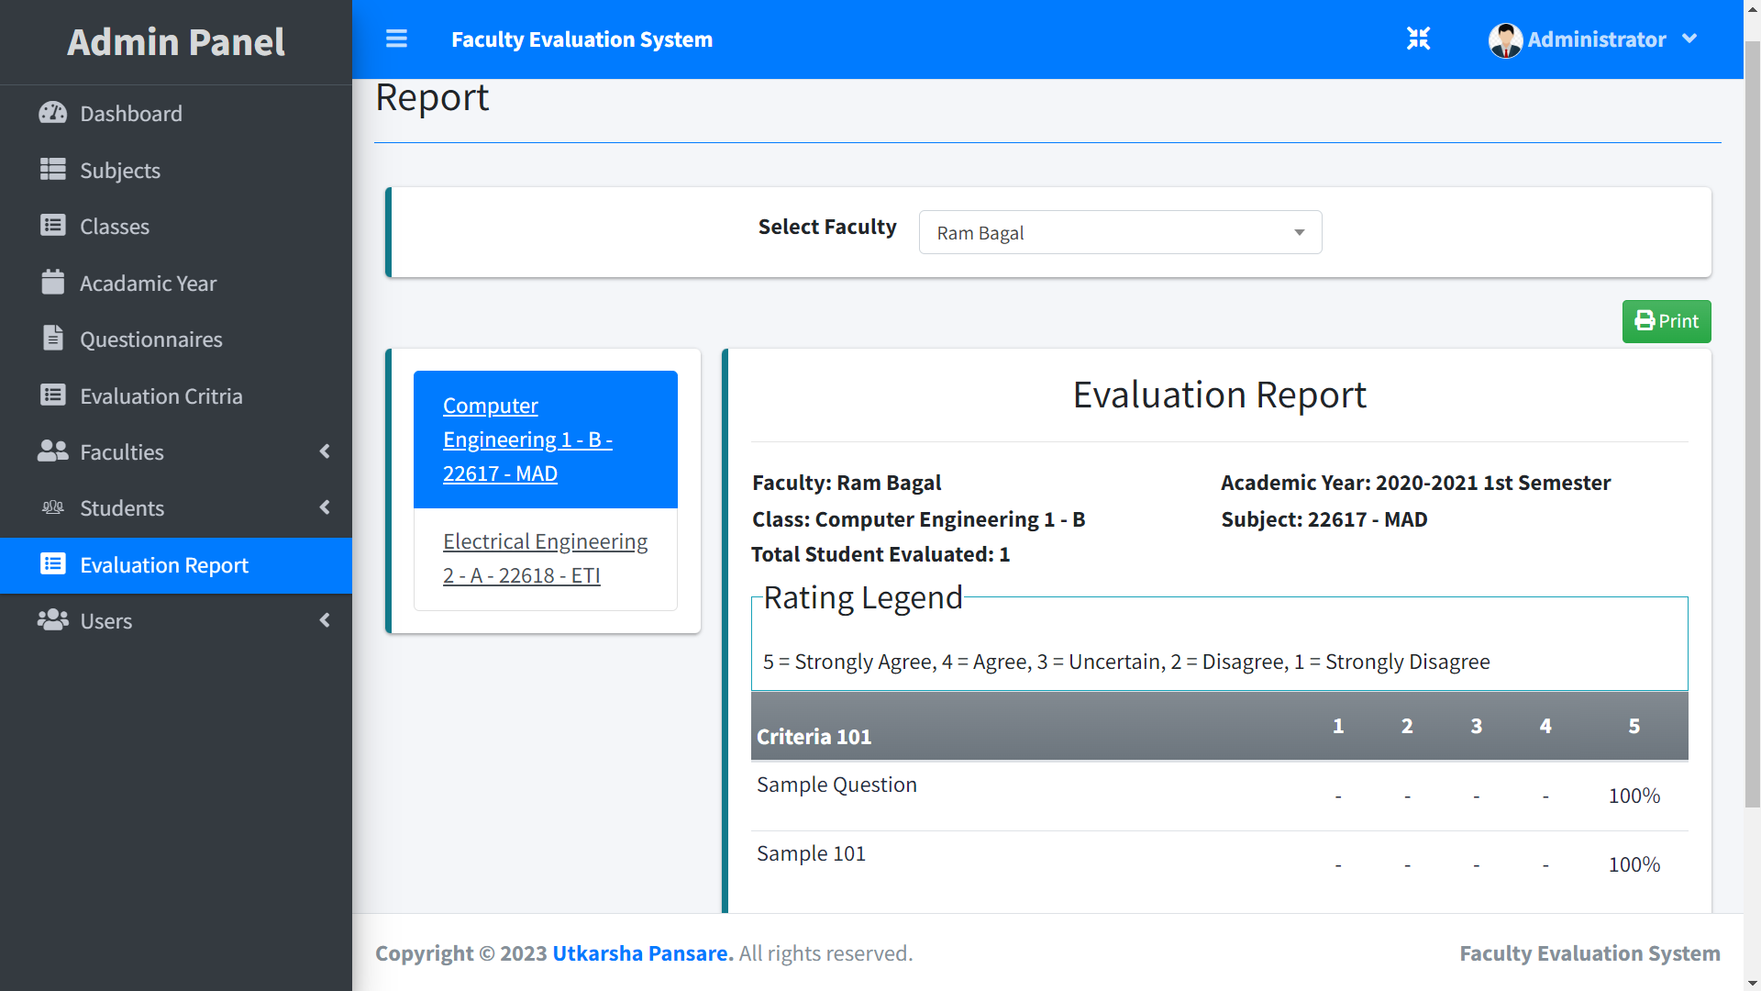

**Admin User List**

**Student Home Page**

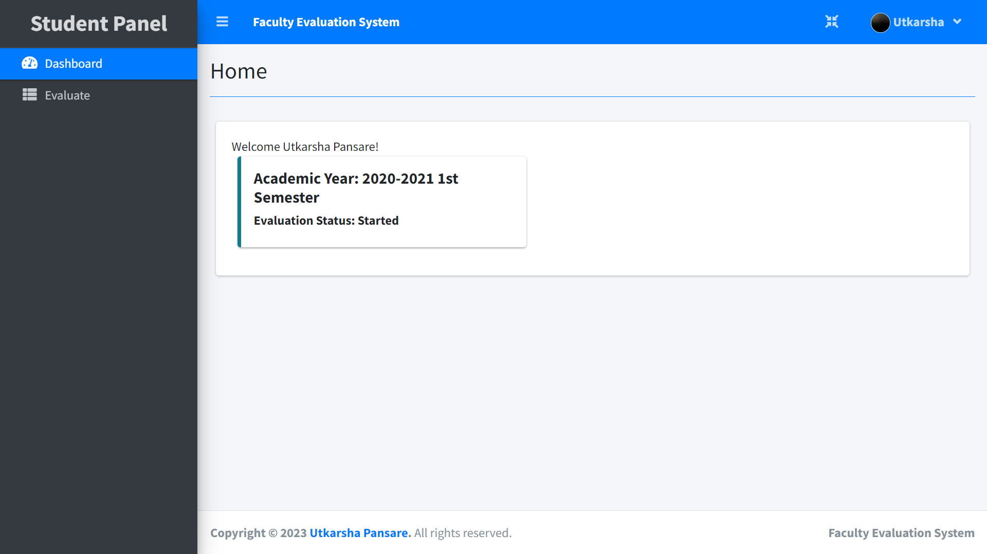

**Evaluation Page**

**Faculty Home Page**

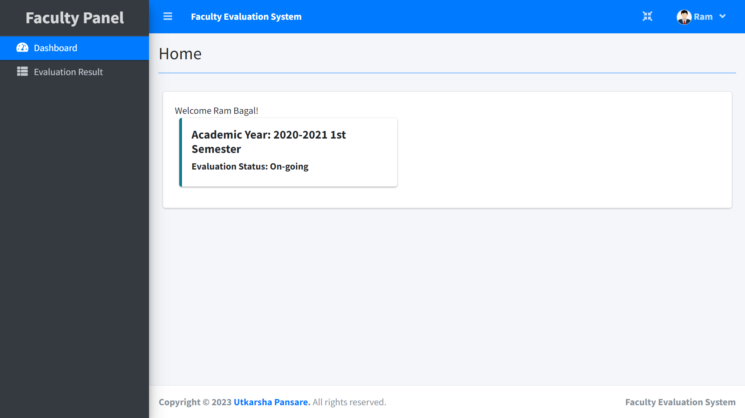

**Results Page For Faculty**

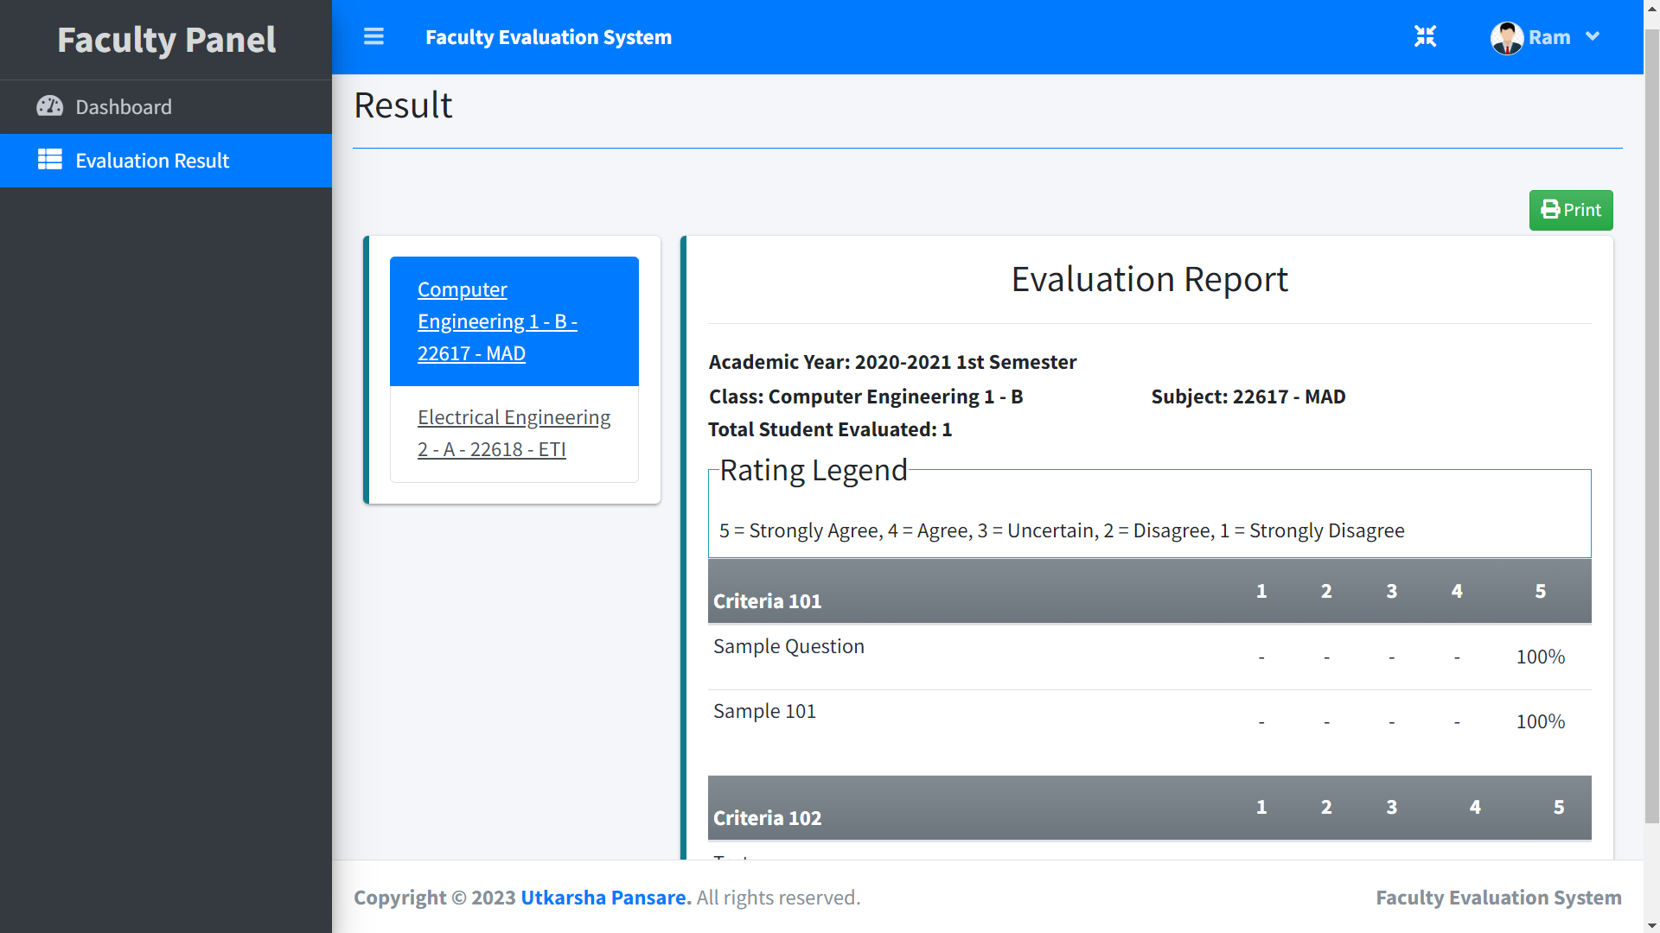

**Options for Edit Profile**

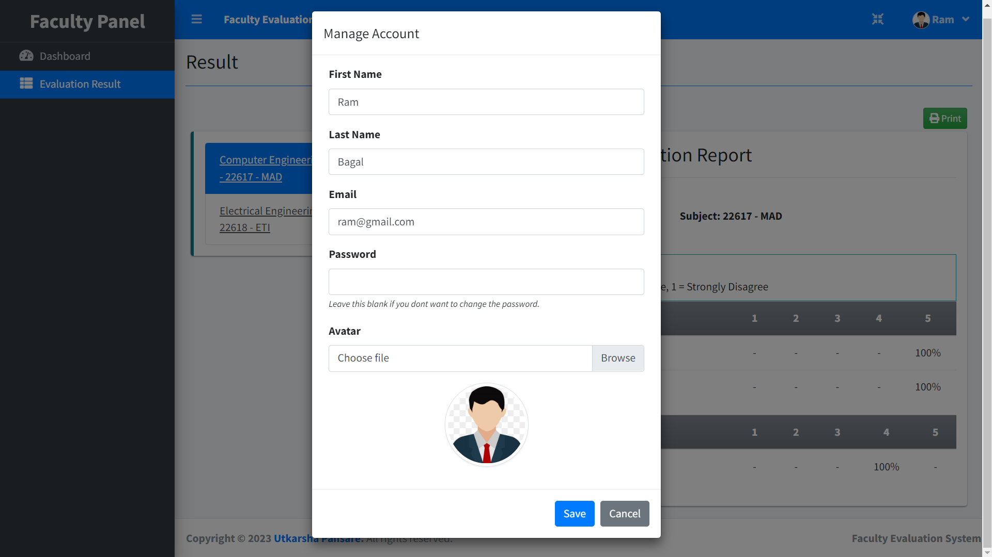

**Chapter-10**

**FUTURE ENHANCEMENT**

**Chapter-10**

**FUTURE ENHANCEMENT**

**Future Enhancement:**

Integration of Artificial Intelligence: Integrating artificial intelligence (AI) algorithms into feedback systems could help to automatically analyze and categorize feedback responses, providing more detailed and actionable insights.

Personalized Feedback: Future feedback systems could use personalized data to provide feedback that is tailored to individual students' needs and preferences. For example, feedback could be customized based on a student's learning style, interests, or previous academic performance.

Real-time Feedback: Real-time feedback could be provided during the course rather than at the end of the semester. This would enable instructors to make adjustments to their teaching methods and course materials more quickly, resulting in a more responsive learning environment.

Use of Multimodal Feedback: Feedback systems could use multiple modes of feedback, such as video, audio, and text-based feedback, to provide a more comprehensive and nuanced understanding of student perceptions.

Integration with Learning Analytics: Feedback systems could be integrated with learning analytics tools to provide instructors with real-time data on student performance, engagement, and learning outcomes. This would enable instructors to identify areas of concern more quickly and make adjustments to the course accordingly.

**Chapter-11**

**CONCLUSION**

**Chapter-11**

**CONCLUSION**

In conclusion, feedback systems are an important tool for universities and colleges to improve teaching quality and enhance student satisfaction. By providing students with a platform to share their opinions and experiences, feedback systems enable instructors and university administrators to make informed decisions about teaching methods, course content, and other important aspects of the learning environment.

While there are limitations to feedback systems, such as potential bias in feedback and limited actionability of results, these systems remain a valuable tool for improving teaching quality and enhancing the learning experience for students.

In the future, feedback systems may be enhanced with the integration of artificial intelligence, personalized feedback, real-time feedback, multimodal feedback, and integration with learning analytics tools. These enhancements have the potential to make feedback systems even more effective tools for improving teaching quality and enhancing student learning outcomes.

**BIBLOGRAPHY**

**BIBLOGRAPHY**

1. Hattie, J., & Timperley, H. (2007). The power of feedback. Review of Educational Research, 77(1), 81-112.
2. Boud, D., & Molloy, E. (2013). Rethinking models of feedback for learning: The challenge of design. Assessment & Evaluation in Higher Education, 38(6), 698-712.
3. Carless, D., & Boud, D. (2018). The development of student feedback literacy: Enabling uptake of feedback. Assessment & Evaluation in Higher Education, 43(8), 1315-1325.
4. Nguyen, T. Q., & Vargo, J. (2014). The effect of feedback type and anonymity on student performance in online quizzes. Journal of Educational Computing Research, 50(2), 207-223.
5. Rust, C., & Price, M. (2011). Feedback loops: Encouraging dialogue in the feedback process. Assessment & Evaluation in Higher Education, 36(4), 417-427.
6. Yang, M., & Guo, J. (2016). Online feedback system for improving teaching quality in higher education. Journal of Educational Technology Development and Exchange, 9(1), 1-16.
7. Yorke, M. (2013). Peer feedback in higher education: Reconsidering the student and teacher as the feedback-givers. Higher Education, 65(3), 277-292.
8. Nicol, D. J., & Macfarlane‐Dick, D. (2006). Formative assessment and self‐regulated learning: A model and seven principles of good feedback practice. Studies in Higher Education, 31(2), 199-218.